Monthly Report 5

- Date of Report:1/3/10/2025
- Student ID - Name: ISSAM AL AWAMLEH 21110241
- Major: CYBER SECRUITY
- Company: JODDB
- Department: cyber shield academy
- Industry Mentor: Abdullaah al masri, Yoseef halaseh
- Apprenticeship Mentor: Shareef Shargawi
- Working days/hours:5 days (8AM-3PM)

Your report must cover these topics:
- Your role and responsibilities this month (+ evidence) :
My role was cyber security trainee but this month and after it my Mentor is Abdullah almari and Yoseef halaseh I was helping the academy to organizing the cybersecurity courses(DIFRA , Incident response) also marching on to have CWSE(Certified Web Security Expert):
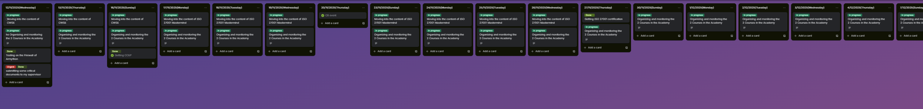

- Any problems / Challenges and how did you overcome them?
Trying to organize more than course that was a challenge for me and the level of the CWSE was medium to hard level that made me keep moving in it slowly.

- Any training courses you attended during the apprenticeship, whether you opted for independently or through the employer.
  - Name of the course: CWSE certified web security expert from Havkviser(individually)
  - Main Topics: Web Penetration testing
  - Copy of certification: on progress
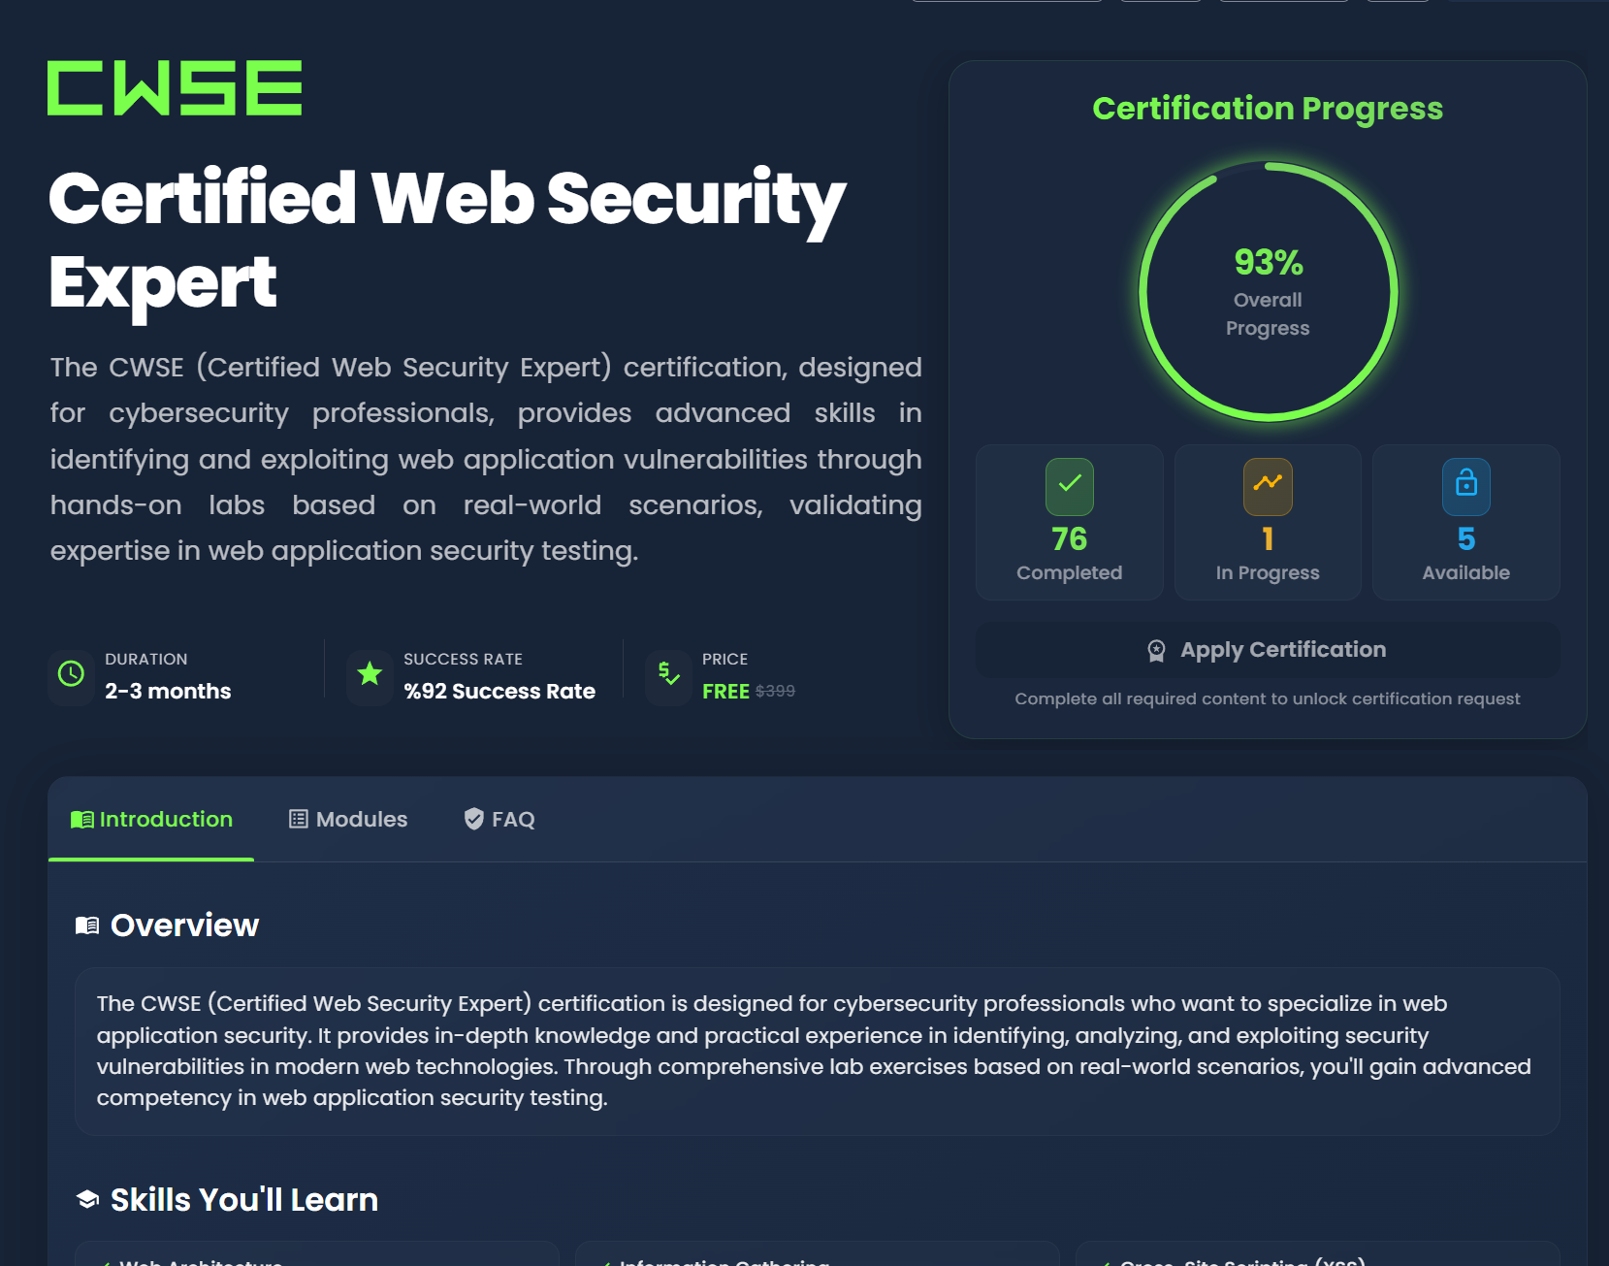

- What software /tools did you use?
GitHub, Burp suite, hackviser, VPN, VMware, virtual box, kali OS, SSH service, Microsoft Word, Microsoft excel.

- Technical and non-technical skills
Teamwork, Patient ,Adoptability ,research skill, Critical tasks management, Work under the pressure, communication skills, multi-tasking, Time management, problem solving, organizing and fast learning.

- Did you work on the National Occupational Standards (NOSs):
  - How many NOSs did you complete out of 5?1/5
  - List of NOSs (Number (URN) – Name of NOS)
  - TECIS610501 Manage intrusion detection and analysis

- Events / Conferences you participated in
Armython (C8 event) 18-20 November 2025

- Your Plan for Next Month.
- Getting CWSE(Certification web security expert) from Hackviser.
- Keep developing the site for the instructor.

